Option #2: NLP Chatbot Project Draft

Edmond Tucker
Colorado State University Global
CSC525: Principles of Machine Learning
Dong Nguyen, Dr.
7 April 2024

Option #2: NLP Chatbot Project Draft
Creating an interactive advice chatbot which leverages advanced natural language processing and machine learning to offer personalized and adaptive date ideas involves an artificial intelligence technology-driven approach. Combining the linguistic natural language of GPT-3 with real-time information from APIs such as MapBox, the chatbot seeks to fine-tune recommendations based on user feedback and machine learning.
Project Goals
- Develop a chatbot that delivers personalized date ideas, leveraging user preferences and local data.
- Utilize GPT-3 for generating human-like, nuanced responses and MapBox API for integrating local, real-time data.
- Implement machine learning, specifically regression models, to adapt and refine recommendations based on user interactions.
Tools and Technologies
- GPT-3: For understanding and generating responses in natural language.
- MapBox API: To provide localized, up to date information for date suggestions.
- TensorFlow/PyTorch and Scikit-learn: For building and applying the adaptive learning model.
Implementation Strategy
- Data Integration and Preparation: Collect user data through basic initial questionnaire with follow on option and integrate with MapBox for local insights.
- Building the Chatbot:
  - Use GPT-3 for the chatbot's language capabilities.
  - Develop a data integration module for fetching and processing local data.
  - Implement a learning and adaptation module using TensorFlow or PyTorch, incorporating regression analysis to learn from user feedback.
- User Interaction and Feedback Loop: Design an intuitive interface for user interactions. Implement a feedback mechanism to capture user satisfaction and preferences, feeding this data back into the model for continuous improvement.
Initial Script Progress
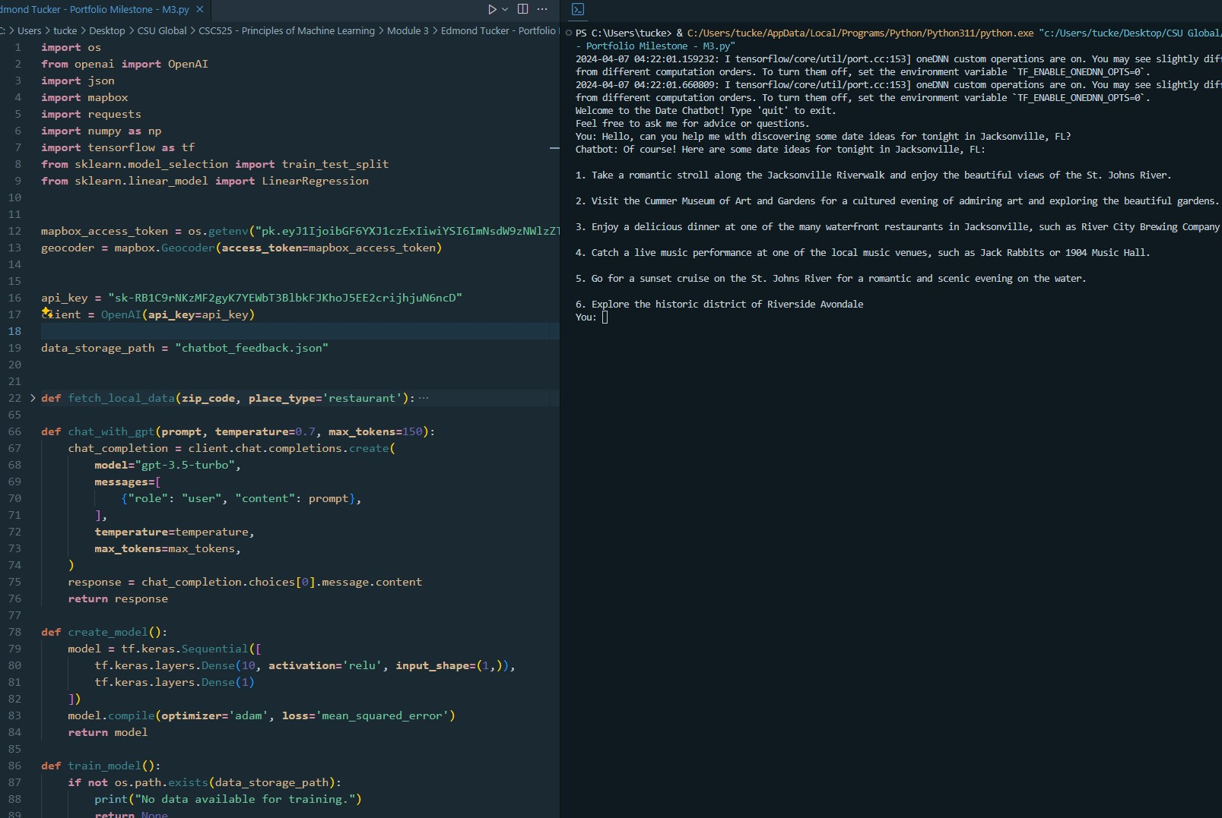
Deployment and Evaluation
Begin with a questionnaire phase to gather initial user preferences, followed by iterative refinement. A final evaluation will assess the chatbot's ability to engage users, the accuracy of its personalized suggestions, and its learning efficacy over time.
Conclusion
This project aims for a personalized chatbot by marrying advanced AI with user-centric adaptability. This chatbot is poised to offer a unique blend of personalization, engagement, and utility in the realm of relationship advice concerning localized ideas for creating a “date”.

